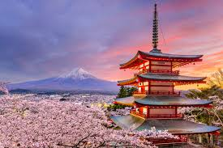

**Discover the beauty of Japan**

Japan, a land where ancient traditions meet modern technology, creating a unique and fascinating experience. From the streets of Tokyo, filled with cutting-edge technology and vibrant nightlife, to the scenes of temples of Kyoto.

Japan offers a diverse array of attractions that cater to every traveler’s dream.